
1 Understanding J2EE Architecture using JSP, SERVLETS, Beans and JDBC
2 Understanding JSP

Develop a JSP application to display access count of the webpage using sessions.
02. Assume the existence of database named “Inventory” which contains the table
a. “Product” with necessary information like Product ID (varchar), Product name (varchar), supplier ID (varchar), stock available(number), opening stock (number), last supply date (Date), unit price (number).
b. “Supplier” containing Supplier ID (varchar), Suppler Name (varchar), Email (varchar), Mobile Phone number (varchar)
c. “User” containing UserId (varchar), Username (varchar), password (varchar), role (varchar- Allowed values are {DEO,POS,MGR})
Develop a JSP page to
d. Add new product. Prevent duplication of Product ID and entering non existing supplier ID.
e. Fetch product based on ID
f. View the list of products for which stock available is less than 50

DATABASE
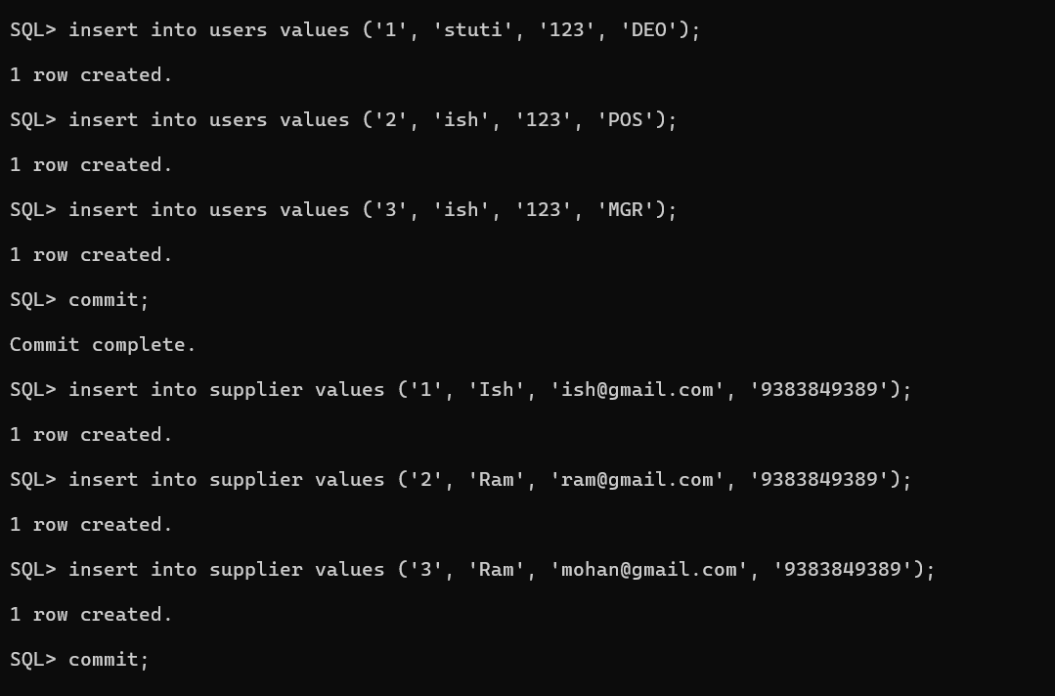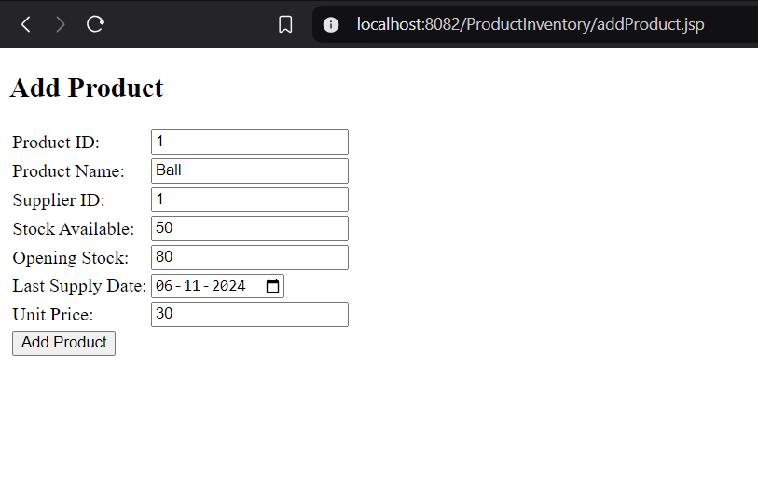
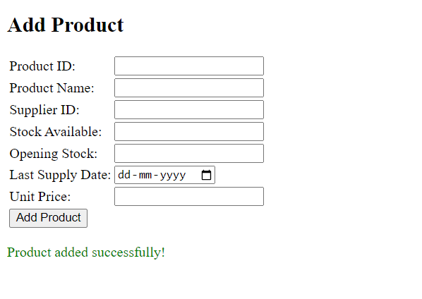
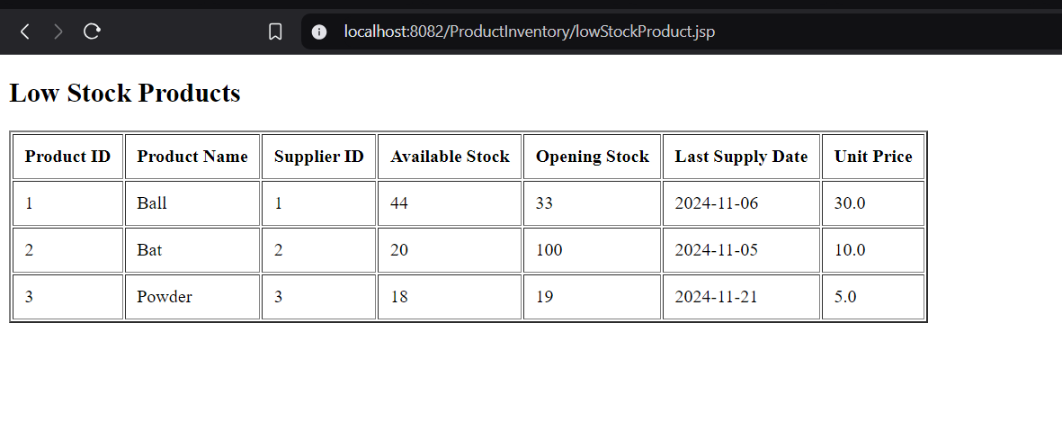
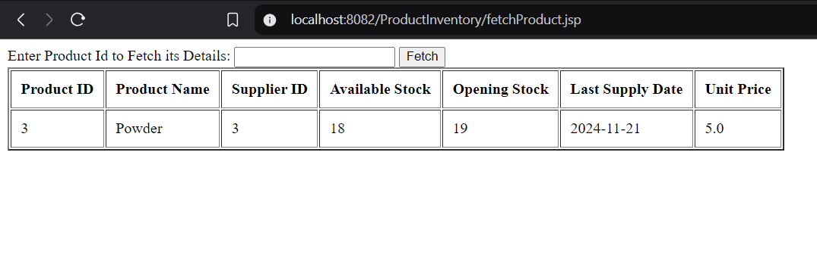
Index.jsp
<%@ page import="java.sql.*" %>
<%@ page language="java" contentType="text/html; charset=UTF-8" pageEncoding="UTF-8"%>
<!DOCTYPE html>
<html>
<head>
<meta charset="UTF-8">
<title>Login</title>
</head>
<body>

<%
String username = request.getParameter("username");
String password = request.getParameter("password");
String errorMessage = null;

if (username != null && password != null) {
Connection conn = null;
PreparedStatement stmt = null;
ResultSet rs = null;

try {
// Load the Oracle JDBC driver
Class.forName("oracle.jdbc.driver.OracleDriver");

// Database connection details
String dbURL = "jdbc:oracle:thin:@localhost:1521:xe";
String dbUser = "system";
String dbPassword = "admin";

// Establish the database connection
conn = DriverManager.getConnection(dbURL, dbUser, dbPassword);

// SQL query to check if the user exists
String sql = "SELECT role FROM users WHERE username LIKE ? AND password LIKE ?";
stmt = conn.prepareStatement(sql);
stmt.setString(1, username);
stmt.setString(2, password);
rs = stmt.executeQuery();

if (rs.next()) {
// User authenticated successfully, create session
session = request.getSession(true);
session.setAttribute("username", username);
response.sendRedirect("welcome.jsp?role="+rs.getString("role").toString());
} else {
// Authentication failed
errorMessage = "Invalid Username or Password!";
}
} catch (Exception e) {
e.printStackTrace();
errorMessage = "Database connection error!";
} finally {
// Close the resources
if (rs != null) rs.close();
if (stmt != null) stmt.close();
if (conn != null) conn.close();
}
}
%>

<h2>Login Page</h2>
<form method="post">
<table>
<tr>
<td>Username:</td>
<td><input type="text" name="username" required></td>
</tr>
<tr>
<td>Password:</td>
<td><input type="password" name="password" required></td>
</tr>
<tr>
<td colspan="2">
<input type="submit" value="Login">
</td>
</tr>
</table>
</form>

<%
if (errorMessage != null) {
%>
<p style="color: red;"><%= errorMessage %></p>
<%
}
%>

</body>
</html>

Welcome.jsp
<%@ page language="java" contentType="text/html; charset=UTF-8"
pageEncoding="UTF-8"%>
<!DOCTYPE html>
<html>
<head>
<meta charset="UTF-8">
<title>Welcome</title>
</head>
<body>
Hi <%= session.getAttribute("username") %><br><br>
<%
String role = request.getParameter("role");
if(role.equals("POS")){%>
<strong><a href = "fetchProduct.jsp">Fetch Product</a></strong><br><br>
<%}
if(role.equals("DEO")){%>
<strong><a href = "addProduct.jsp" >Add Product</a></strong><br><br>
<%}
if(role.equals("MGR")){%>
<strong><a href = "lowStockProduct.jsp">Low Stock Product</a></strong><br><br>
<%}
%>
</body>
</html>

fetchProduct.jsp
<%@ page language="java" import="java.sql.*" contentType="text/html; charset=UTF-8"
pageEncoding="UTF-8"%>
<!DOCTYPE html>
<html>
<head>
<meta charset="UTF-8">
<title>Fetch Product</title>
</head>
<body>
<form method="post">
Enter Product Id to Fetch its Details: <input name="ProductID" type="text" required/>
<input type="submit" value="Fetch"/>
</form>
<%
String pid = request.getParameter("ProductID");
if (pid != null) {
Connection conn = null;
PreparedStatement pstmt = null;
ResultSet rs = null;
try {
Class.forName("oracle.jdbc.driver.OracleDriver");
conn = DriverManager.getConnection("jdbc:oracle:thin:@localhost:1521:xe", "system", "admin");
String sql = "SELECT * FROM PRODUCT WHERE ProductID = ?";
pstmt = conn.prepareStatement(sql);
pstmt.setString(1, pid);
rs = pstmt.executeQuery(); // Execute the prepared statement

if (rs.next()) {
// Display table headers
%>
<table border="2" cellpadding="10">
<tr>
<th>Product ID</th>
<th>Product Name</th>
<th>Supplier ID</th>
<th>Available Stock</th>
<th>Opening Stock</th>
<th>Last Supply Date</th>
<th>Unit Price</th>
</tr>
<%
// Display the product details
%>
<tr>
<td><%= rs.getString("ProductID") %></td>
<td><%= rs.getString("ProductName") %></td>
<td><%= rs.getString("SupplierID") %></td>
<td><%= rs.getInt("StockAvailable") %></td>
<td><%= rs.getInt("OpeningStock") %></td>
<td><%= rs.getDate("LastSupplyDate") %></td>
<td><%= rs.getDouble("UnitPrice") %></td>
</tr>
</table>
<%
} else {
%>
<p>No products found. <a href="addProduct.jsp"><strong>Add Products</strong></a></p>
<%
}
} catch (Exception e) {
e.printStackTrace();
} finally {
if (rs != null) rs.close();
if (pstmt != null) pstmt.close(); // Corrected from stmt to pstmt
if (conn != null) conn.close();
}
}
%>
</body>
</html>

AddProduct.jsp
<%@ page import="java.sql.*" %>
<%@ page language="java" contentType="text/html; charset=UTF-8" pageEncoding="UTF-8"%>
<!DOCTYPE html>
<html>
<head>
<meta charset="UTF-8">
<title>Add Product</title>
</head>
<body>

<%
String productID = request.getParameter("ProductID");
String productName = request.getParameter("ProductName");
String supplierID = request.getParameter("SupplierID");
String stockAvailable = request.getParameter("StockAvailable");
String openingStock = request.getParameter("OpeningStock");
String lastSupplyDate = request.getParameter("LastSupplyDate");
String unitPrice = request.getParameter("UnitPrice");

String errorMessage = null;
boolean productAdded = false;

if (productID != null && productName != null && supplierID != null && stockAvailable != null && openingStock != null && lastSupplyDate != null && unitPrice != null) {
Connection conn = null;
PreparedStatement stmt = null;
ResultSet rs = null;

try {
// Load Oracle JDBC Driver
Class.forName("oracle.jdbc.driver.OracleDriver");

// Connect to the Oracle Database
String dbURL = "jdbc:oracle:thin:@localhost:1521:xe";
String dbUser = "system";
String dbPassword = "admin";
conn = DriverManager.getConnection(dbURL, dbUser, dbPassword);

// Check if ProductID already exists
String checkProductSQL = "SELECT ProductID FROM Product WHERE ProductID = ?";
stmt = conn.prepareStatement(checkProductSQL);
stmt.setString(1, productID);
rs = stmt.executeQuery();
if (rs.next()) {
errorMessage = "Product ID already exists!";
} else {
// Check if SupplierID exists in Supplier table
String checkSupplierSQL = "SELECT SupplierID FROM Supplier WHERE SupplierID = ?";
stmt = conn.prepareStatement(checkSupplierSQL);
stmt.setString(1, supplierID);
rs = stmt.executeQuery();
if (!rs.next()) {
errorMessage = "Supplier ID does not exist!";
} else {
// Insert the new product
String insertSQL = "INSERT INTO Product (ProductID, ProductName, SupplierID, StockAvailable, OpeningStock, LastSupplyDate, UnitPrice) VALUES (?, ?, ?, ?, ?, TO_DATE(?, 'YYYY-MM-DD'), ?)";
stmt = conn.prepareStatement(insertSQL);
stmt.setString(1, productID);
stmt.setString(2, productName);
stmt.setString(3, supplierID);
stmt.setInt(4, Integer.parseInt(stockAvailable));
stmt.setInt(5, Integer.parseInt(openingStock));
stmt.setString(6, lastSupplyDate); // Date in format 'YYYY-MM-DD'
stmt.setDouble(7, Double.parseDouble(unitPrice));
stmt.executeUpdate();
productAdded = true;
}
}
} catch (Exception e) {
e.printStackTrace();
errorMessage = "Database error occurred!";
} finally {
// Close resources
if (rs != null) rs.close();
if (stmt != null) stmt.close();
if (conn != null) conn.close();
}
}
%>

<h2>Add Product</h2>
<form method="post">
<table>
<tr>
<td>Product ID:</td>
<td><input type="text" name="ProductID" required></td>
</tr>
<tr>
<td>Product Name:</td>
<td><input type="text" name="ProductName" required></td>
</tr>
<tr>
<td>Supplier ID:</td>
<td><input type="text" name="SupplierID" required></td>
</tr>
<tr>
<td>Stock Available:</td>
<td><input type="number" name="StockAvailable" required></td>
</tr>
<tr>
<td>Opening Stock:</td>
<td><input type="number" name="OpeningStock" required></td>
</tr>
<tr>
<td>Last Supply Date:</td>
<td><input type="date" name="LastSupplyDate" required></td>
</tr>
<tr>
<td>Unit Price:</td>
<td><input type="number" step="0.01" name="UnitPrice" required></td>
</tr>
<tr>
<td colspan="2">
<input type="submit" value="Add Product">
</td>
</tr>
</table>
</form>

<% if (errorMessage != null) { %>
<p style="color: red;"><%= errorMessage %></p>
<% } else if (productAdded) { %>
<p style="color: green;">Product added successfully!</p>
<% } %>

</body>
</html>

lowStockProduct.jsp
<%@ page language="java" import = "java.sql.*" contentType="text/html; charset=UTF-8"
pageEncoding="UTF-8"%>
<!DOCTYPE html>
<html>
<head>
<meta charset="UTF-8">
<title>Low Stock Product</title>
</head>
<body>
<h2>Low Stock Products</h2>
<%
Connection conn = null;
Statement stmt = null;
ResultSet rs = null;
try {
Class.forName("oracle.jdbc.driver.OracleDriver");
conn = DriverManager.getConnection("jdbc:oracle:thin:@localhost:1521:xe", "system", "admin");
String sql = "SELECT * FROM PRODUCT WHERE StockAvailable < 50";
stmt = conn.createStatement();
rs = stmt.executeQuery(sql);

if (rs.next()) {
// Display table headers
%>
<table border="2" cellpadding="10">
<tr>
<th>Product ID</th>
<th>Product Name</th>
<th>Supplier ID</th>
<th>Available Stock</th>
<th>Opening Stock</th>
<th>Last Supply Date</th>
<th>Unit Price</th>
</tr>
<%
do {
%>
<tr>
<td><%= rs.getString("ProductID") %></td>
<td><%= rs.getString("ProductName") %></td>
<td><%= rs.getString("SupplierID") %></td>
<td><%= rs.getInt("StockAvailable") %></td>
<td><%= rs.getInt("OpeningStock") %></td>
<td><%= rs.getDate("LastSupplyDate") %></td>
<td><%= rs.getDouble("UnitPrice") %></td>
</tr>
<%
} while (rs.next());
%>
</table>
<%
} else {
%>
<p>No products found. <a href="addProduct.jsp"><strong>Add Products</strong></a></p>
<%
}
} catch (Exception e) {
e.printStackTrace();
} finally {
if (rs != null) rs.close();
if (stmt != null) stmt.close();
if (conn != null) conn.close();
}
%>
</body>
</html>

Understanding Java Networking and RMI
01. Develop a TCP based client –server application using java.net.*. Let the client transfers the operation in the format of ‘A + B’ and server in turn interprets the operator, perform the requested operation using the operands and transmits the result to get displayed in client.
TCPClient.java
package TCPOperand;

import java.io.BufferedReader;
import java.io.InputStreamReader;
import java.io.PrintWriter;
import java.net.Socket;

public class TCPClient {
public static void main(String[] args) {
String serverAddress = "localhost";
int port = 1234;

try (Socket socket = new Socket(serverAddress, port);
BufferedReader input = new BufferedReader(new InputStreamReader(socket.getInputStream()));
PrintWriter output = new PrintWriter(socket.getOutputStream(), true);
BufferedReader consoleInput = new BufferedReader(new InputStreamReader(System.in))) {

System.out.println("Enter an operation in the format 'A + B':");
String operation = consoleInput.readLine();
output.println(operation);

String response = input.readLine();
System.out.println("Server response: " + response);
} catch (Exception e) {
System.out.println("Client exception: " + e.getMessage());
}
}
}

TCPServer.java
package TCPOperand;
import java.io.BufferedReader;
import java.io.InputStreamReader;
import java.io.PrintWriter;
import java.net.ServerSocket;
import java.net.Socket;

public class TCPServer {
public static void main(String[] args) {
try (ServerSocket serverSocket = new ServerSocket(1234)) {
System.out.println("Server is listening on port 1234");
while (true) {
try (Socket socket = serverSocket.accept();
BufferedReader input = new BufferedReader(new InputStreamReader(socket.getInputStream()));
PrintWriter output = new PrintWriter(socket.getOutputStream(), true)) {

String expression = input.readLine();
String[] tokens = expression.split(" ");
int operand1 = Integer.parseInt(tokens[0]);
String operator = tokens[1];
int operand2 = Integer.parseInt(tokens[2]);

int result = 0;
switch (operator) {
case "+":
result = operand1 + operand2;
break;
case "-":
result = operand1 - operand2;
break;
case "*":
result = operand1 * operand2;
break;
case "/":
if (operand2 != 0) {
result = operand1 / operand2;
} else {
output.println("Error: Division by zero");
continue;
}
break;
default:
output.println("Error: Unknown operator");
continue;
}

output.println("Result: " + result);
} catch (Exception e) {
System.out.println("Error: " + e.getMessage());
}
}
} catch (Exception e) {
System.out.println("Server exception: " + e.getMessage());
}
}
}

02. Design a UDP application in which sender broadcasts the message and the receiver computes count of each character in a message.
import java.net.DatagramPacket;
import java.net.DatagramSocket;
import java.net.InetAddress;
import java.net.SocketException;

public class UDPCountChar {
public static DatagramSocket ds;
public static byte buffer[] = new byte[1024];
public static void server() {
System.out.println("SERVER is up");
try {
int pos = 0;
while(true) {
int ch = System.in.read();
switch(ch) {
case '\n' : ds.send(new DatagramPacket(buffer, pos, InetAddress.getLocalHost(),6666));
pos = 0;
break;
default : buffer[pos++] = (byte)ch;
break;
}
}
} catch (Exception e) {
e.printStackTrace();
}
}

public static void client() {
System.out.println("CLIENT is up");
try {
int pos = 0;
while(true) {
DatagramPacket p = new DatagramPacket(buffer, buffer.length);
ds.receive(p);
String str = new String(p.getData(), 0 ,p.getLength()).trim();
System.out.println("Received : "+ str);
int cnt[] = new int[26];
for(int i=0; i<str.length(); i++) {
if(str.charAt(i) - 'a' < 26){
cnt[str.charAt(i) - 'a']++;
}
}
System.out.println("Character counts :- ");
for(int i=0; i<26; i++) {
if(cnt[i]!= 0)
System.out.println((char)(i+'a') + " : " + cnt[i]);
}
}
} catch (Exception e) {
e.printStackTrace();
}
}

public static void main(String[] args) throws SocketException {
if (args.length == 1){
ds = new DatagramSocket(5555);
server();
} else {
ds = new DatagramSocket(6666);
client();
}
}
}
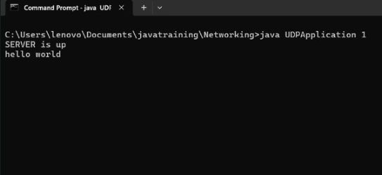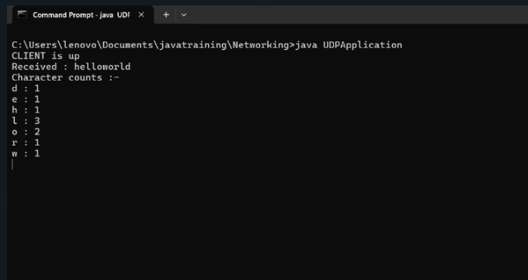
03. Implement an RMI application to invoke a factorial method with appropriate parameter deployed in server and display the result in client.
import java.rmi.Remote;
import java.rmi.RemoteException;

public interface Factorial extends Remote {
int computeFactorial(int n) throws RemoteException;
}

import java.rmi.RemoteException;
import java.rmi.server.UnicastRemoteObject;

public class FactorialImpl extends UnicastRemoteObject implements Factorial {
protected FactorialImpl() throws RemoteException {
super();
}

@Override
public int computeFactorial(int n) throws RemoteException {
if (n <= 1) return 1;
return n * computeFactorial(n - 1);
}
}
import java.rmi.Naming;
import java.rmi.registry.LocateRegistry;

public class FactorialServer {
public static void main(String[] args) {
try {
LocateRegistry.createRegistry(1099);
FactorialImpl factorial = new FactorialImpl();
Naming.rebind("rmi://localhost:1099/FactorialService", factorial);
System.out.println("Factorial Service is running...");
} catch (Exception e) {
System.err.println("Server exception: " + e.toString());
e.printStackTrace();
}
}
}
import java.rmi.Naming;

public class FactorialClient {
public static void main(String[] args) {
try {
Factorial factorial = (Factorial) Naming.lookup("rmi://localhost:1099/FactorialService");
int number = 5; // Example number to calculate factorial
int result = factorial.computeFactorial(number);
System.out.println("Factorial of " + number + " is " + result);
} catch (Exception e) {
System.err.println("Client exception: " + e.toString());
e.printStackTrace();
}
}
}

